**Project Report**

**Project titile :**

**ShopEZ:One-Stop Shop for Online Purchases :**

**Introduction :**

ShopEZ is a full-stack e-commerce web application designed to provide users with a seamless online shopping experience. This platform allows customers to browse a wide variety of products, add items to a shopping cart, place secure orders, and manage their personal order history.

The application also includes an admin dashboard, enabling the admin to manually add, manage, and delete products from the storefront without accessing the code. The system ensures role-based access, where regular users can shop and view orders, while only the admin (with specific login credentials) has privileges to manage product inventory.

Developed using the MERN stack (MongoDB, Express, React, Node.js), ShopEZ follows a modular and scalable architecture, integrates Redux for state management, and utilizes RESTful APIs for data operations. The user interface is built with responsive design principles to ensure usability across devices.

# Ideation Phase Brainstorm & Idea Prioritization Template

|  |  |
| --- | --- |
| Date | 27 June 2025 |
| Team ID | LTVIP2025TMID21133 |
| Project Name | ShopEZ:One-Stop Shop for Online Purchases |
| Maximum Marks | 4 Marks |

**Brainstorm & Idea Prioritization Template:**

Brainstorming provides a free and open environment that encourages everyone within a team to participate in the creative thinking process that leads to problem solving. Prioritizing volume over value, out-of-the-box ideas are welcome and built upon, and all participants are encouraged to collaborate, helping each other develop a rich amount of creative solutions.

Use this template in your own brainstorming sessions so your team can unleash their imagination and start shaping concepts even if you're not sitting in the same room.

**Step-1: Team Gathering, Collaboration and Select the Problem Statement**

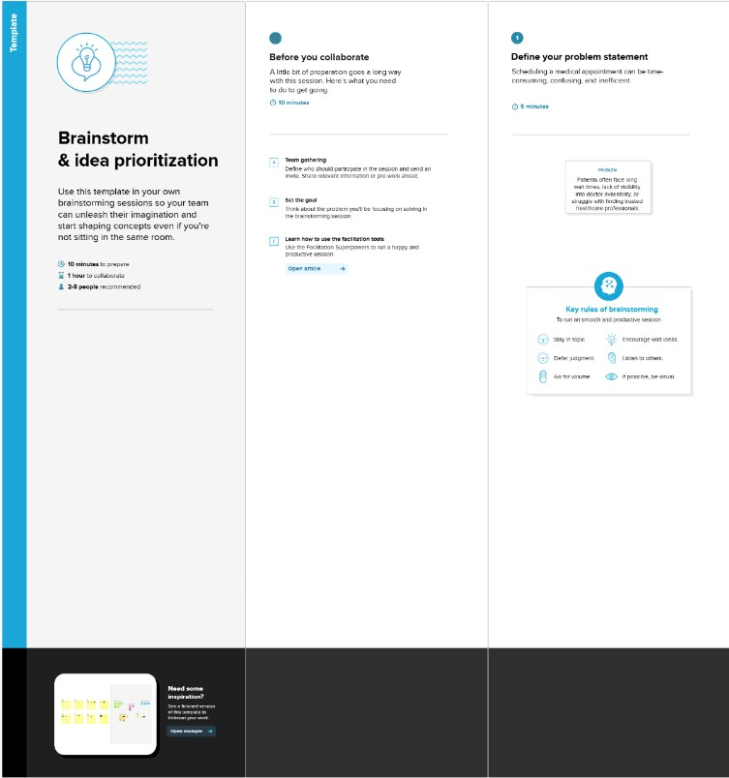

**Step-2: Brainstorm, Idea Listing and Grouping**

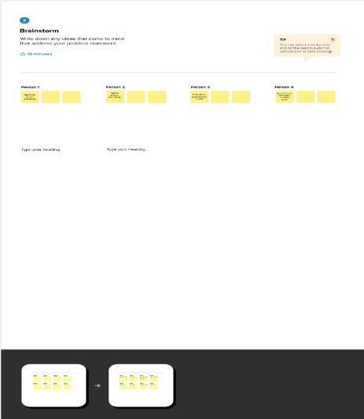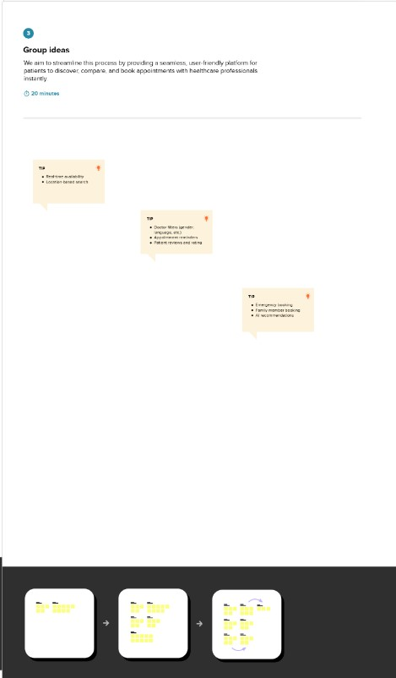

**Step-3: Idea Prioritization**

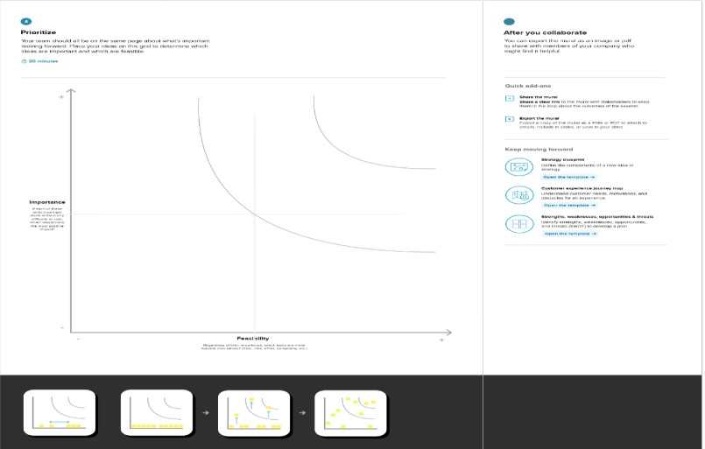

# Ideation Phase Define the Problem Statements

|  |  |
| --- | --- |
| Date | 27 June 2025 |
| Team ID | LTVIP2025TMID21133 |
| Project Name | ShopEZ:One-Stop Shop for Online Purchases |
| Maximum Marks | 2 Marks |

**Customer Problem Statement :**

|  |  |  |  |  |  |
| --- | --- | --- | --- | --- | --- |
| **Problem**  **Statement (PS)** | **I am**  **(Customer)** | **I’m trying to** | **But** | **Because** | **Which makes me feel** |
| PS-1 | a working professional with a tight schedule | book a customer order quickly without phone calls or long wait times. | most clinics don’t have real-time booking systems or clear availability info | their systems are outdated or fragmented | frustrated and anxious about my health getting worse while waiting. |

In today's fast-paced digital world, customers face the hassle of juggling between multiple online platforms to shop for different product categories like fashion, electronics, groceries, and personal care. This fragmented shopping experience leads to wasted time, inconsistent quality, shipping delays, and a lack of centralized customer support. Customers want a single, trustworthy platform that provides a seamless, reliable, and efficient shopping experience across all product categories.

**Key Customer Pain Points:**

* Too many apps/sites for different needs
* Inconsistent pricing and delivery
* No centralized support for diverse purchases
* Time wasted comparing products across platforms
* Limited access to verified reviews and offers in one place

|  |  |  |  |  |  |
| --- | --- | --- | --- | --- | --- |
| PS-2 | a general physician running a small clinic. | manage customer  bookings  efficiently and reduce no-shows. | my current tools are manual or not tailored  to healthcare workflows. | I can’t  afford or understand  complex  clinic  manageme nt systems. | stressed and underpaid despite my busy schedule. |

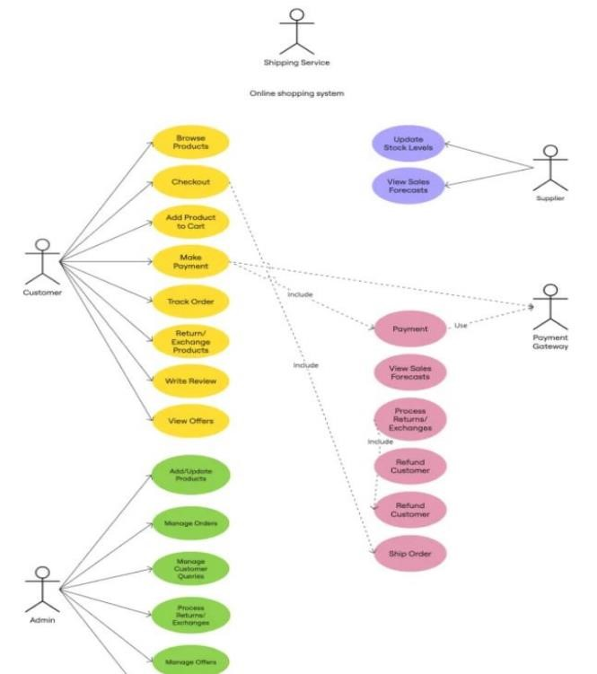

**Ideation Phase**

**Empathize & Discover**

|  |  |
| --- | --- |
| Date | 27 June 2025 |
| Team ID | LTVIP2025TMID21133 |
| Project Name | ShopEZ:One-Stop Shop for Online Purchases |
| Maximum Marks | 4 Marks |

**Empathy Map Canvas:**

An empathy map is a simple, easy-to-digest visual that captures knowledge about a user’s behaviours and attitudes.

It is a useful tool to helps teams better understand their users.

Creating an effective solution requires understanding the true problem and the person who is experiencing it. The exercise of creating the map helps participants consider things from the user’s ctive along with his or her goals and challenges.

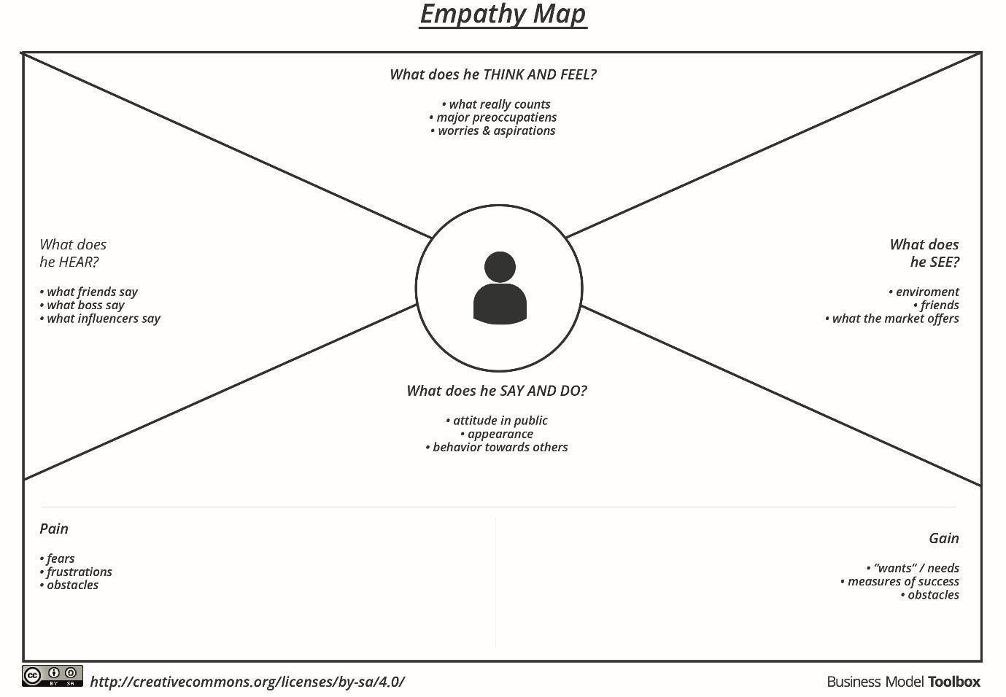

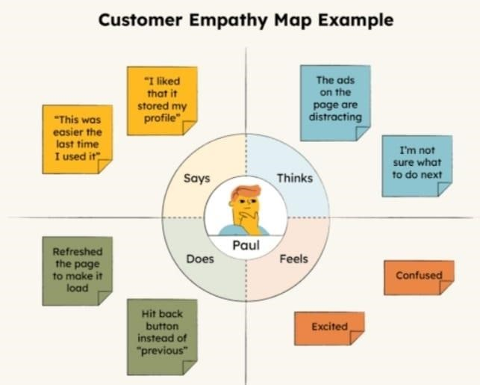

# User Acceptance Testing (UAT)

|  |  |
| --- | --- |
| Date | 27 June 2025 |
| Team ID | LTVIP2025TMID21133 |
| Project Name | ShopEZ:One-Stop Shop for Online Purchases |
| Maximum Marks | 4 marks |

**Project Overview:**

Project Description :A user-friendly platform that allows customers to book, reschedule, and manage medical orders with healthcare professionals. Features include doctor search, real-time availability, a order booking, video consultation, digital prescriptions, and calendar integration.

Project Version:v1.0.0

Testing Period: 2025-06-15 to 2025-06-27 **Testing Scope:**

* customer registration and login
* Search and filter for doctors
* Real-time orders booking
* Reschedule and cancel orders
* Video consultation module
* Digital prescriptions
* O rders reminders (SMS/email)
* Payment integration
* Review and rating system

***Requirements to be Tested:***

* As a patient, I want to easily search and book appointments with available doctors.

* As a doctor, I want to manage my availability and bookings.

* As a user, I want secure login, video consultations, and payments.

* As an admin, I want to manage users and handle disputes or feedback.

**Testing Environment:**

**Testing Environment**

**URL:** https://customer\example.com

**Credentials:**

* **customer:** user1@gmail.com / custmer123

* **Admin:** admin@gmail.com / admin123

**Test Cases:**

|  |  |  |  |  |  |
| --- | --- | --- | --- | --- | --- |
| **Test Case**  **ID** | **Test Scenario** | **Test Steps** | **Expected**  **Result** | **Actual**  **Result** | **Pass/Fail** |
| TC-001 | User  Registration | 1. Visit site 2. Click "Sign Up" 3. Fill & submit form | Profile saved | Account created, redirected to dashboard | [Pass/Fail] |
| TC-002 | customer Profile  Creation | 1. Login as customer 2. Fill bio & availability 3. Save | Profile saved,  listed in search results | Account created, redirected  to dashboard | [Pass/Fail] |
| TC-003 | Order requirements | 1. Search the product 2. Select quantity 3. Confirm booking | Booking confirmed  and shown in user dashboard | Order will booked | [Pass/Fail] |

**Bug Tracking: product tracking**

|  |  |  |  |  |  |
| --- | --- | --- | --- | --- | --- |
| **Bug ID** | **Bug**  **Description** | **Steps to reproduce** | **Severity** | **Status** | **Additional feedback** |
| BG-001 | Filter not working properly | 1. Search with location  + specialty | Medium | Open | Only partial  results shown |
| ... | ... | ... | ... | ... | ... |

**Sign-off:**

Tester Name: charishma

Date: 27-05-2025

Signature: charishma

**Notes:**

* Test across **multiple devices and browsers**.

* Cover **positive and negative** cases (e.g., invalid input, empty search, etc.).

* Track all bugs with reproduction steps and severity.

* Sign-off is required from the **project manager** and **product owner** before release.

**Project Design Phase**

**Proposed Solution Template**

|  |  |
| --- | --- |
| Date | 27 June 2025 |
| Team ID | LTVIP2025TMID21133 |
| Project Name | ShopEZ:One-Stop Shop for Online Purchases |
| Maximum Marks | 2 Marks |

**Proposed Solution for ShopEZ Online Purchases App :**

|  |  |  |
| --- | --- | --- |
| **S. No.** | **Parameter** | **Description** |
| **1** | **Problem**  **Statement** (Problem to be solved) | Customers often face long wait times, inconvenient appointment scheduling, and poor communication with healthcare providers. On the provider side, managing slots, follow-ups, and patient data remains inefficient. |
| **2** | **Idea /**  **Solution**  **Description** | ShopEZs a full-stack healthcare appointment booking platform that connects patients with healthcare providers. It features real-time availability, secure appointment scheduling, digital payments, and reminders. Admin tools help manage users and service quality. |
| **3** | **Novelty /**  **Uniqueness** | * Real-time appointment availability * Role-based access for patients/doctors/admins * Secure payment integration * SMS/email reminders * Option for teleconsultation (video call integration) |
| **4** | **Social Impact**  **/ Customer**  **Satisfaction** | * Reduces patient wait times and no-shows * Empowers rural or remote access to care via telehealth * Enhances patient-provider communication * Digitally transforms outdated booking systems |
| **5** | **Business**  **Model**  **(Revenue**  **Model)** | -Freemium model for clinics with basic features   * Subscription for advanced features (analytics, teleconsultation, branded portal) * Transaction fee on payments (optional) * White-label B2B partnerships with hospitals |
| **6** | **Scalability of the Solution** | Designed for clinics, hospitals, and telehealth startups   * Global-ready with multi-language, multi-timezone, and multi-currency support * Mobile-first UX with future React Native or Flutter app * Modular microservices-based backend for flexibility |

## Project Design Phase Solution Architecture

|  |  |
| --- | --- |
| Date | 27 June 2025 |
| Team ID | LTVIP2025TMID21133 |
| Project Name | ShopEZ:One-Stop Shop for Online Purchases |
| Maximum Marks | 4 Marks |

**Solution Architecture:**

To provide a user-friendly, secure, and scalable orders booking system that bridges the gap between products.

* Effortless Orders Booking
* End-to-End customer Management
* Scalable user authentication and authorization
* Secure and trackable payment transactions
* Reliable real-time chat and notifications

**Solution Architecture Diagram:**

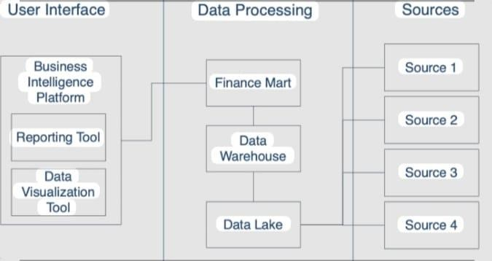

## Project Planning Phase

**Project Planning Template (Product Backlog, Sprint Planning, Stories, Story points)**

|  |  |  |  |  |  |  |
| --- | --- | --- | --- | --- | --- | --- |
| **Sprint** | **Functional**  **Requirement**  **(Epic)** | **User**  **Story**  **Number** | **User Story / Task** | **Story**  **Points** | **Priori ty** | **Team Member**  **s** |
| **Sprint**  **-1** | **User**  **Authenticatio n** | USN-1 | As a user, I can sign up and log in securely. | 3 | High |  |
|  |  | USN-2 | As a user, I can reset my password. | 2 | Medi um |  |
| **Sprint**  **-2** | **customer**  **Discovery &**  **Booking** | USN-3 | As a customer, I can search and filter products by location/speciality. | 2 | High |  |
| **Sprint**  **-3** | **Profile**  **Management** | USN-4 | As a customer, I can set up and update my profile and availability. | 3 | High |  |
|  |  | USN-5 | As a user, I can update my profile information. | 2 | High |  |
|  |  | USN-6 | As a user, I can send/receive messages. | 2 | Medi um |  |
| **Sprint**  **-4** | **Payment**  **Integration &**  **Reviews** | USN-7 | As a client, I can pay freelancers securely. | 3 | High |  |

|  |  |
| --- | --- |
| Date | 27 June 2025 |
| Team ID | LTVIP2025TMID21133 |
| Project Name | ShopEZ:One-Stop Shop for Online Purchases |
| Maximum Marks | 5 Marks |

**Product Backlog, Sprint Schedule, and Estimation (4 Marks)**

**Product Backlog & Sprint Schedule**

|  |  |  |  |  |  |  |
| --- | --- | --- | --- | --- | --- | --- |
| **Sprint** | **Total**  **Story**  **Points** | **Durati on** | **Sprint**  **Start Date** | **Sprint End Date**  **(Planned)** | **Story Points Completed (as on**  **Planned End Date)** | **Sprint Release**  **Date (Actual)** |
| **Sprint-1** | 20 | 6 Days | 1 May  2025 | 2 june 2025 | 20 | 2 june 2025 |
| **Sprint-2** | 20 | 6 Days | 3 May  2025 | 4 june 2025 | 20 | 4 june 2025 |
| **Sprint-3** | 20 | 6 Days | 5 May  2025 | 6 june 2025 | 20 | 6 june 2025 |
| **Sprint-4** | 20 | 6 Days | 7 May  2025 | 8 june 2025 | 20 | 8 june 2025 |

|  |  |  |  |  |  |  |
| --- | --- | --- | --- | --- | --- | --- |
|  |  | USN-8 | As a user, I can leave a review after project completion. | 2 | Medi um |  |
|  |  | USN-9 | As a user, I can change my password. | 2 | Medi um |  |
|  |  |  |  |  |  |  |

**Project Tracker, Velocity & Burndown Chart**

**Project Design Phase-II**

**Data Flow Diagram & User Stories**

|  |  |
| --- | --- |
| Date | 27 June 2025 |
| Team ID | LTVIP2025TMID21133 |
| Project Name | ShopEZ:One-Stop Shop for Online Purchases |
| Maximum Marks | 4 Marks |

**Data Flow Diagrams:**

A **Data Flow Diagram (DFD)** illustrates how data moves within the Freelance Finder platform. It captures how users (freelancers and clients) interact with the system, how information flows between different components, and where the data is stored.

Example: DFD Level 0 (Industry Standard)

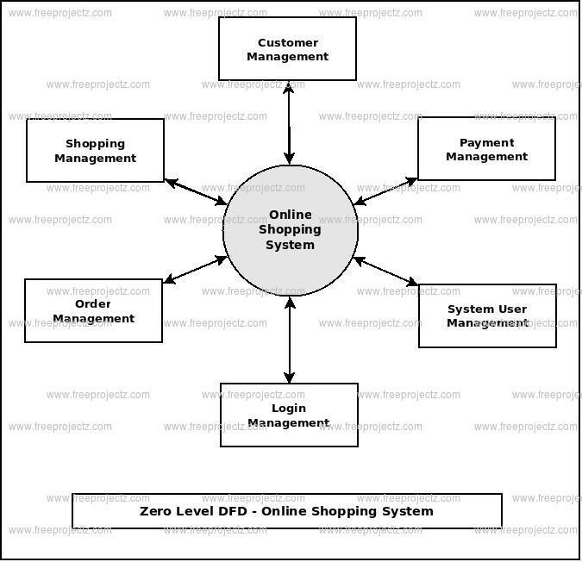

**User Stories**

|  |  |  |  |
| --- | --- | --- | --- |
| **User Type** | **Functional**  **Requirement**  **(Epic)** | **User Story / Task** | **Acceptance Criteria** |
| **customer** | Orders  Booking | As a customer, I can search for products by specialty and location. | Search results return relevant products |
|  |  | As a patient, I can book, reschedule, or cancel orders. | Appointment status upd accordingly. |
| **Healthcare**  **Provider** | Schedule  Management | As a provider, I can manage my availabil | Changes reflect immediately in patient booking system. |
| **User** | Messaging | As a user, I can chat with the other party in real-time. | Messages appear instan |
| **Admin** | Profile  Management | As a Admin, I can update my profile. | Changes are saved successfully. |
| **Client** | Payment  Processing | As a client, I can make secure payments after job completion. | Payment recorded and shown in transaction his |
| **user** | Review System | As a user, I can leave a review after project closure. | Review appears on prof |

**User Story Table – Shopez**

### Project Design Phase-II

**Solution Requirements (Functional & Non-functional)**

|  |  |
| --- | --- |
| Date | 27 June 2025 |
| Team ID | LTVIP2025TMID21133 |
| Project Name | ShopEZ:One-Stop Shop for Online Purchases |
| Maximum Marks | 4 Marks |

**Functional Requirements:**

Following are the functional requirements of the proposed solution.

|  |  |  |  |
| --- | --- | --- | --- |
| **Admin** | User Moderation | As an admin, I can review reported users and take action. | Reports and actions log |

**Functional Requirements – Music Streaming App**

|  |  |  |
| --- | --- | --- |
| **FR No.** | **Functional Requirement (Epic)** | **Sub Requirement (Story / Sub-Task)** |
| **FR-1** | User Authentication | Sign up, Login, Password Reset |
|  |  | OAuth login using Google / GitHub |
| **FR-2** | **Orders Booking** | Search orders by specialty, location, and availability |
|  |  | Book, reschedule, and cancel orders |
| **FR-3** | **Calendar & Schedule Management** | Freelancers apply to jobs |
|  |  | View upcoming and past orders |
| **FR-4** | **Notifications & Reminders** | Automated SMS/email reminders for upcoming order |

**Non-functional Requirements:**

Following are the non-functional requirements of the proposed solution.

|  |  |  |
| --- | --- | --- |
| **NFR No.** | **Non-Functional**  **Requirement** | **Description** |
| **NFR-**  **1** | **Usability** | The platform should provide a simple, clean and care products |
| **NFR-**  **2** | **Security** | All customer and order data must be encrypted. Implement rolebased access and secure authentication |
| **NFR-**  **3** | **Reliability** | order booking, notifications, and telehealth services must be available and dependable at all times. |
| **NFR-**  **4** | **Performance** | Pages and booking actions should load within 2 seconds; reminders and notifications should be timely. |
| **NFR-**  **5** | **Availability** | The system should ensure 99.9% uptime with minimal downtime. |
| **NFR-**  **6** | **Scalability** | Support a growing number of users, providers, and concurrent bookings without degradation. |

### Project Design Phase-II Technology Stack (Architecture & Stack)

|  |  |
| --- | --- |
| Date | 27 June 2025 |
| Team ID | LTVIP2025TMID21133 |
| Project Name | ShopEZ:One-Stop Shop for Online Purchases |
| Maximum Marks | 4 Marks |

**Technical Architecture:**

|  |  |  |  |
| --- | --- | --- | --- |
| **S.N**  **o** | **Component** | **Description** | **Technology** |
| 1. | User Interface | Web and mobile-friendly interface for patients and providers | HTML, CSS, JavaScript / React Js etc. |
| 2. | Application Logic-1 | orders booking, calendar management, reminders | Node.js, Express.js |
| 3. | Application Logic-2 | Admin panel, provider management, reporting | React js, Node js |

SHOPEZ is designed with a scalable 3-tier architecture consisting of:

* **Presentation Layer (Frontend):** User-friendly interface for patients and healthcare providers to book and manage appointments.

* **Business Logic Layer (Backend):** Handles appointment scheduling, notifications, user management, and telehealth integration.

* **Data Storage Layer:** Secure storage of user profiles, orders records, and products details details.

The platform integrates with third-party APIs for notifications (SMS/email) and services to enhance usability.

**Table-1 : Components & Technologies:**

**Table-2: Application Characteristics:**

|  |  |  |  |
| --- | --- | --- | --- |
| **S.N**  **o** | **Component** | **Description** | **Technology** |
| 1. | User Interface | Web and mobile-friendly interface for patients and providers | HTML, CSS, JavaScript / React Js etc. |
| 4. | Database | Stores user profiles, orders, products datas | MongoDB |

|  |  |  |  |
| --- | --- | --- | --- |
| **S.N**  **o** | **Characteristics** | **Description** | **Technology** |
| 5. | Open-Source Frameworks | Frontend frameworks | React.js, Node.js, BootStrap,  Tailwind CSS |
| 6. | Scalable Architecture | 3-tier architecture with RESTful APIs | Microservices |

**OUTPUTS SCREENSHOTS :**

* User Login Page

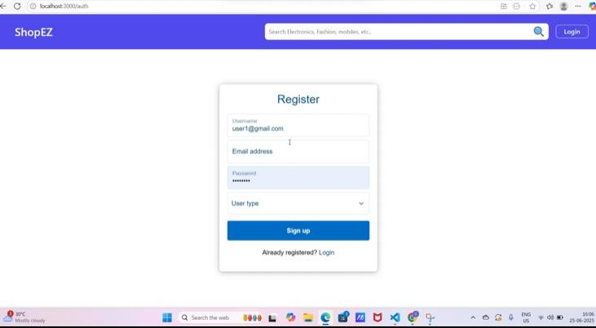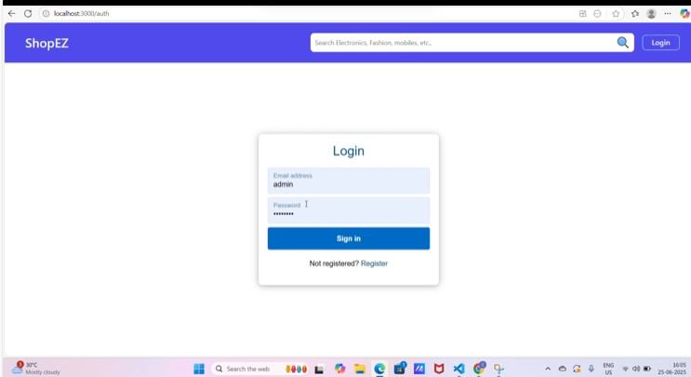

* Product Catalog

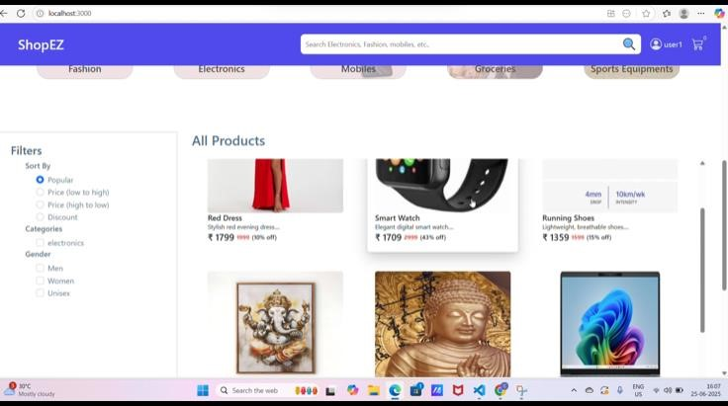

* Admin Dashboard

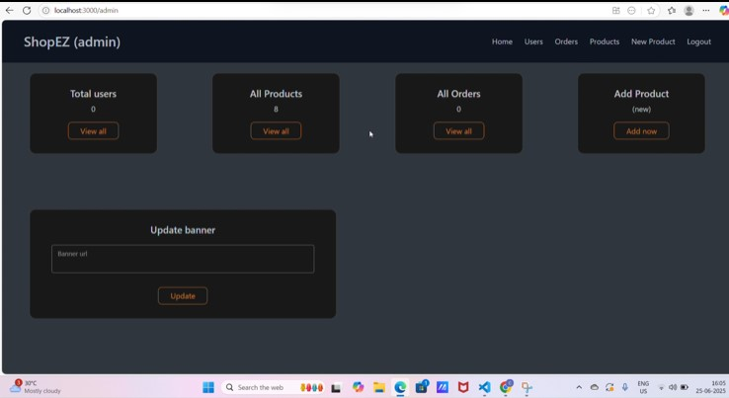

* Landing Page

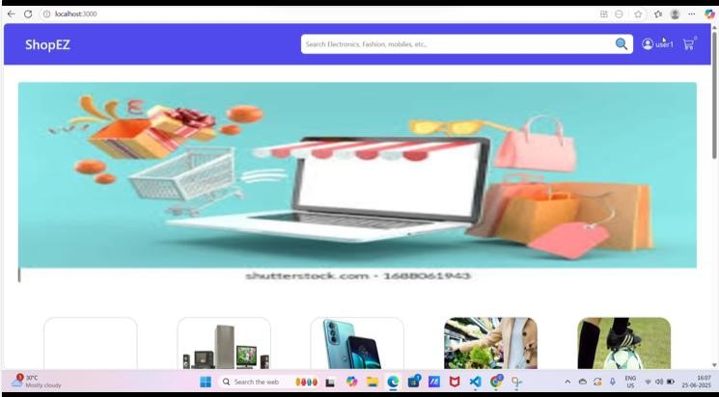

* Cart

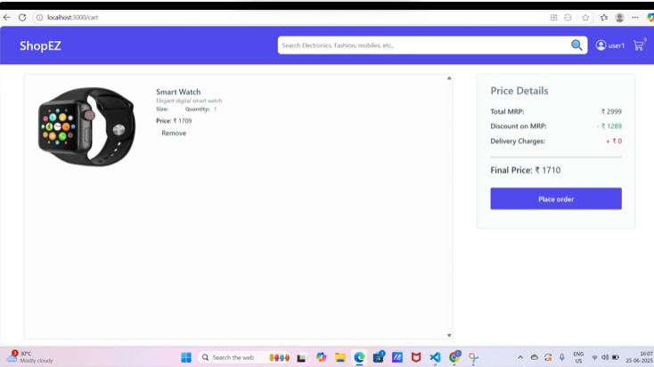

Checkout : payment details

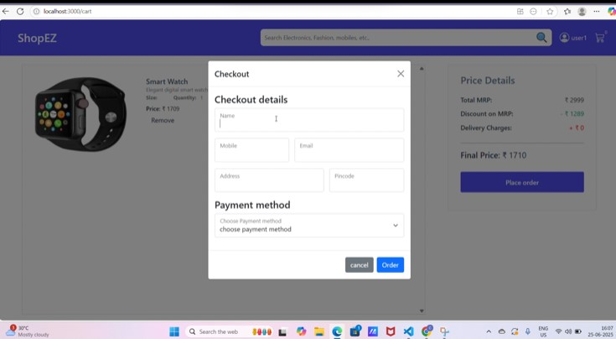

Orders :

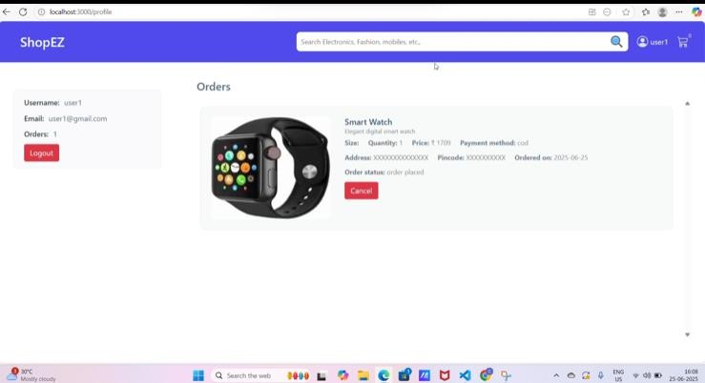

**Advantages and Disadvantages :**

**Advantages:**

1. **User-FriendlyInterface:**

Simple and clean UI that makes it easy for users to browse and purchase products.

1. **Real-TimeCartManagement:**

Users can add, update, or remove products from the cart with instant updates.

1. **AdminDashboard:**

Admins can add or remove products directly from the website without editing any code.

1. **SecureLognSystem:**

Authentication ensures only registered users and the admin can access protected features.

1. **OrderManagement:**

Users can view order history and track their purchases conveniently.

1. **ScalableStructure:**

Built with MERN stack (MongoDB, Express.js, React, Node.js), making it easy to scale or upgrade.

**Disadvantages:**

1. **NoPaymentGatewayIntegration:**

The current system doesn't include actual payment handling (e.g., Razorpay, Stripe).

1. **LimitedProductManagementFeatures:**

No image uploads or advanced stock/inventory management.

1. **BasicErrorHandling:**

Error messages are simple and not user-friendly in all cases.

1. **NoSearchorFilters:**

Users cannot search for products or apply filters (e.g., price range, category).

1. **SingleAdminAccess:**

Admin email is hardcoded, which is not ideal for larger systems.

**Reference Demo link : youtube link demo**

**https://youtu.be/aLXn_ay4bBM?si=bscPiYZvwH8h6Sea**

**Conclusion :**

The **ShopEZ** project successfully demonstrates the development of a fully functional e-commerce platform that meets the essential needs of both customers and administrators. By integrating core features like product browsing, shopping cart management, user authentication, secure checkout, and admin-level product control, the application provides a real-world online shopping experience.

In conclusion , Through this project, we gained hands-on experience in **MERN stack development**, REST API integration, and effective **state management using Redux**. It also allowed us to explore critical aspects of modern web development such as responsive UI design, role-based access control, and real-time data handling.